**Draft Architecture**

* **Normal Flow of Events for Making Reservation-**

|  |  |
| --- | --- |
| Actor | System |
| 1)Customer/Receptionist login. | 2) Accepts valid id/password else rejects. |
| 3)Select room type, Date of arrival and Date of Departure. | 4) Provides information room type available or not and room charges. |
| 5)Apply promotional Code/Coupon. | 6)System provides discounted price. |
| 7) Customer confirms reservation & enter all information related to customer | 8)Generate Reservation No. & Bill. |
| 9) Pay Bill | 10)Generate Receipt. |
|  | 11)Track Check-in Check-out timing. |
| Alternate Flows | |
| 1) Selected Room type not available | 2) Gives Option to add in waiting list.  3) Provides option to select another available room type. |
| 4)User make invalid reservation | 5) System rejects reservation and sends user to start point. |
| 6) User Cancel Reservation | 7)Provides option to make new reservation. |

* **Class Diagram for Hotel Reservation System-**

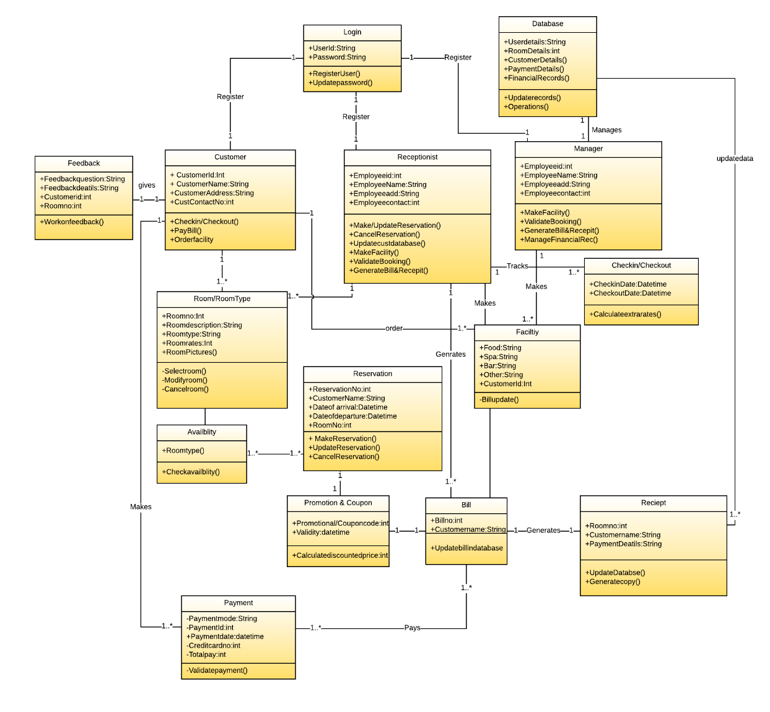

**Lucid Chart Link-**

<https://www.lucidchart.com/invitations/accept/d111e536-2f01-49b6-8342-a217988a7414>

* **Multiplicity of Class Diagram-**

1. 1 User can have 1 Login.
2. 1 Customer can give 1 feedback form.
3. 1 Customer/Receptionist can select 1 or more room type.
4. 1 Customer/Receptionist can reserve one or more available room.
5. 1 or more room type can be available and can be reserved.
6. 1 Customer can make 1 or more payment.
7. 1 Coupon/Promotional Code can be used per bill per reservation.
8. 1 Manager can manage one database system.
9. 1 or more facility can be availed by customer and can be arranged by receptionist.
10. 1 receipt is generated for one bill.
11. 1 receptionist can track 1 or more check-in/check-outs.

* **Interaction diagram balanced with the class diagram-**

1. **Sequence Diagram for Customer**

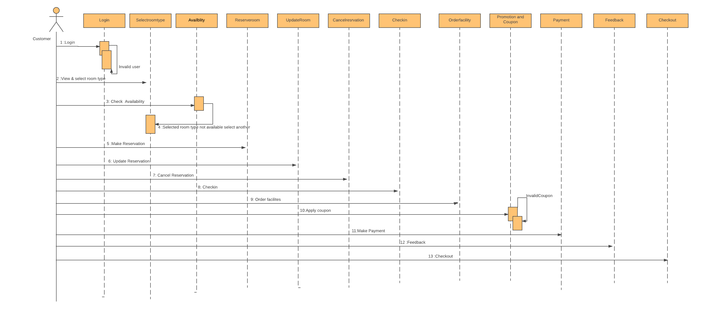

**Lucid chart Link-**

<https://www.lucidchart.com/invitations/accept/d3c2e18f-8b2e-4b03-b856-6945d26dba54>

1. **Sequence Diagram for Receptionist/Manager**

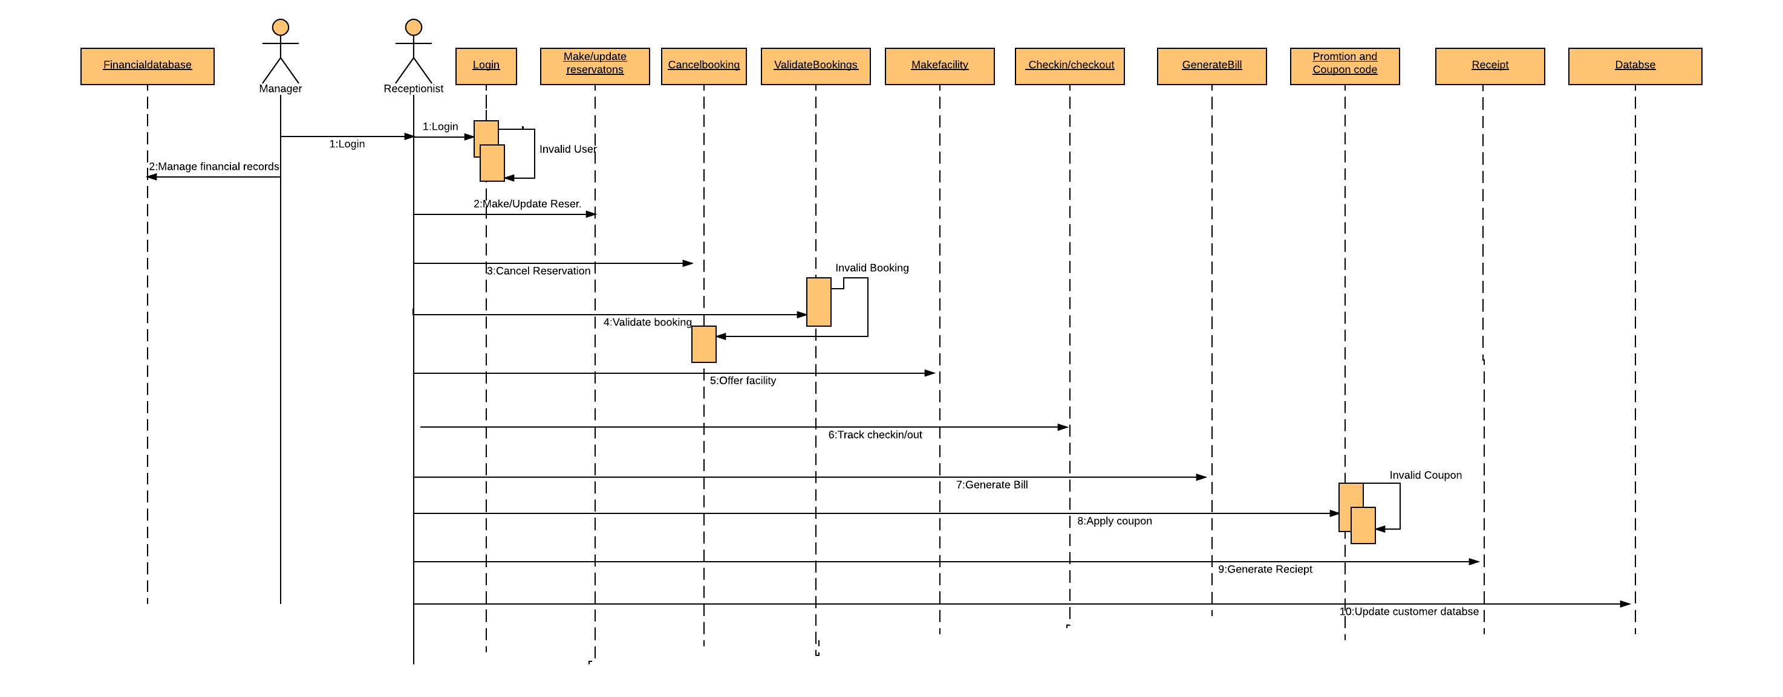

**Lucid chart Link-**

<https://www.lucidchart.com/invitations/accept/16aaab07-408c-4592-adab-c50c5ed0ce22>